Pass Task 5+6 –

Shape Drawer

# Related Learning Outcomes

# ULO1 – Explain the OO Principles

# ULO2 – Use OO Language and Library

This exercise provides a basic example of coding a program in C# using the SwinGame library.

# ULO3 – Design, Develop and Test using an IDE

The task demonstrates how to use perform testing on program algorithm with nUnit in Xamarin studio

# ULO4 – Communicate using UML Diagrams

# ULO5 – Describe Elements of Good OO Design

Code running

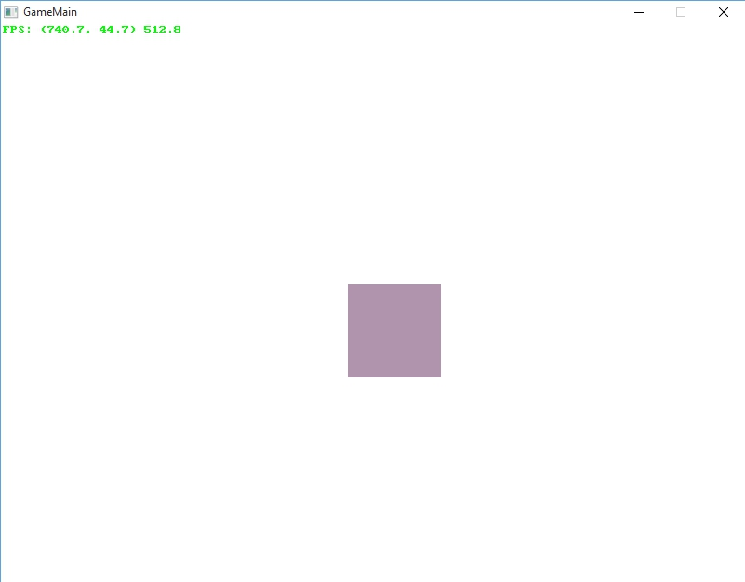

Unit Testing:

